**Integrated HP 英文插图极致享受版**

**INTRODUCTION（放在封面）**

On this page,you will see how Human Practice has promoted the project forward. We did background research and interviewed doctors and patients. At the same time, promotion meetings will be held on the phased achievements of the project. Also, We have an online intercollegiate enterprise exchange with Genscript.

**Overview**

This year, ZJUT-China aims to innovate RNA detection technology for rapid and accurate detection of RNA using cell-free systems. **To this end, HP's philosophy is to listen to the voices of different social groups to gain inspiration for project development while ensuring the usefulness of the project.**

Firstly, we distributed questionnaires to the **general public** to find out what testing technologies are in demand and to clarify what we should work on for our new testing technologies. After that, we interviewed **doctors** as well as **patients** in order to obtain further information about the disease detection technology. With the communication, we have gained a comprehensive knowledge of the existing medical detection systems. We also took the initiative to contact the technical advisor of **GenScript**, a China-based world’s leading **biotech company** providing life sciences services and product, to break through the technical bottleneck. In the process of project R&D, we always remind ourselves to organize and summarize in time. For this purpose, we have established a system of **regular project promotion meetings**. During the meetings, all team members are involved in the discussion of the project progress. This plays a crucial role in the optimization of our projects. We would like to share this working model as a reference for other iGEM teams so that they can carry out their projects more smoothly.

Hp has witnessed the growth of the project through the above-mentioned science communication and is proud to have made outstanding contributions to the formation of the final project. Meanwhile, we are privileged to know that our work is strongly supported by all people and organizations we have come into contact with. We are also very pleased that our results can provide data for other teams.

BACKGROUND INVESTIGATION INTERVIEW COMPANY COMMUNICATION

Biomaker Doctors Genscript

Questionnaires Patients

Experts

**Background Investigation**

**Biomarkers**

**DESCRIPTION**

In the beginning of the project, we didn't have a clear idea of the theme and content, so we wanted to draw inspiration from everyday life. Cancer is a topic that no one wants to talk about because it often means death and suffering. Through the literature, we found that there is a significant correlation between the survival time of cancer patients and the stage when the cancer is detected, and we can assist in the diagnosis of cancer by **testing RNA biomarker**.

We focused on the RNA biomarker and found that it is not only associated with cancer, but also with many inflammatory responses. We have identified some of the RNA biomarkers mentioned in the current literature that are closely related to disease occurrence after searching for a large amount of information.

**VALUES**

This research helped us to further define the project theme and strengthen our determination to detect RNA biomarker. At the same time, this research helped us to build a rich database of biomarkers. Hp shared this database with members of the wet group, who built on it and designed the corresponding igRNAs. **This has led to a disease-biomarker-igRNA database, which we hope can be used to develop rapid detection methods for diseases.**

**NEXT STEPS**

Through our research, we found that the RNA Biomarker CXCL9 has been identified to be closely associated with rejection of kidney transplantation, so our team chose this disease as a research target. A more in-depth study of rejection after kidney transplantation will follow.

（表格威威用代码实现）

**Questionnaires**

**DESCRIPTION**

An **online questionnaire** was conducted to investigate the rejection reaction after kidney transplantation. The questionnaire was designed to understand the public's awareness of kidney transplant rejection and the need for testing technology. The online questionnaire format is not only more in line with the requirements of epidemic prevention, but also helps us to expand the scope of the survey target and dissemination. On May 4, 2021, we posted the questionnaire on multiple social media platforms and received a total of 351 valid questionnaires. Before designing the online questionnaire, we conducted a study of the available detection technologies. **Our background findings can be found by jumping on the link at the bottom.**

**VALUES**

By analyzing the questionnaire data, we found that **although the general public is not new to kidney transplant rejection, they are not aware of the current common detection methods**. This reminds us that we should present the project with a simple knowledge of detection technology. Another thing that caught our attention is that people tend to focus more on the accuracy of the test when faced with the detection method. This guided our dry group and wet group to conduct an in-depth study of the accuracy of the project.

**NEXT STEPS**

After clarifying the public's expectations of the detection technology, we switched our research from the public to the stakeholders, i.e., physicians and patients.



**Interview**

**Doctors**

**DESCRIPTION**

On June 16, we interviewed Dr. Lin Bo, chief physician of Zhejiang Provincial People's Hospital. Before the interview, we did not know much about the current development of clinical detection technology in China. Dr. Lin provided detailed answers to our questions with his mature clinical experience. He said that the current kidney biopsy technology in China is well established, but there are still time and space limitations, as well as a small probability of complications such as blood in the urine, blood stasis, and infection. **Nowadays, the overall trend of hospital detection technology is from invasive to non-invasive, and our project can focus on non-invasive technology that can break through time and space limitations.** Our detailed interview questions can be found by jumping on the link at the bottom.

**VALUES**

This interview further deepened our understanding of the current stage of kidney biopsy technology. **The development trend of non-invasive testing mentioned by Dr. Lin not only further our understanding of invasive detection, but also brought our attention to the current medical experience of invasive testing for patients.** At the end of the interview we gave our results back to the wet group students to assist them in planning their experimental procedures

**NEXT STEPS**

Interviews for kidney transplant patients are conducted in order to fully understand the feelings of the patients.

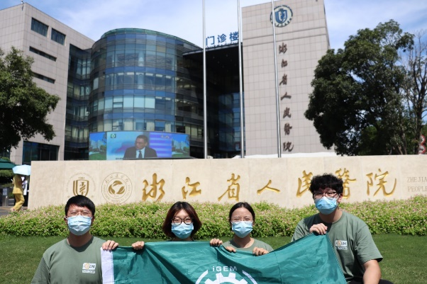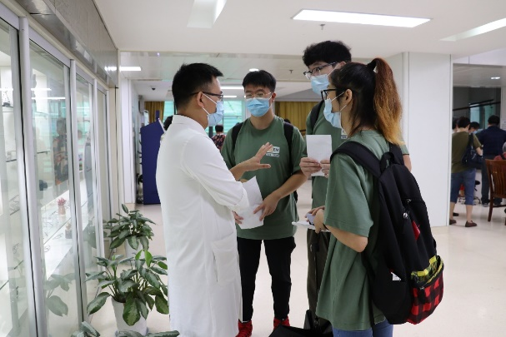



**Patients**

**DESCRIPTION**

On August 30, we conducted a special interview. The interviewee received a **kidney transplant** in 2005 at the age of 35. At the time, the **high cost** of a kidney transplant left her in debt and nearly broke. Fortunately, her surgery went very well and she did not have any rejection reactions. However, misfortune befell another patient. One young man who received a kidney transplant in the same cohort as she did had a rejection reaction three months after the procedure. He needs to maintain his infected kidneys by paying for **expensive medications**. However, the drugs ultimately failed to save his kidney and he had to wait for the next transplant. Remarkably, this was a young man from a wealthy family who was able to pay for his medical expenses and wait for his next kidney transplant. But if the rejection had occurred in our interviewee, the consequences would undoubtedly have been catastrophic.

**VALUES**

Looking at our project only from the perspective of a physician or researcher is undoubtedly **one-sided**. In fact, it is necessary to get to know the people who are served by our program, that is, the patients. This event not only gave us a full understanding of the experience of kidney transplant patients, but also gave us the insight that if our program is convenient and inexpensive enough, and can be free from the limitation of place, time and money, then maybe we can **reduce the medical burden** of patients.

**NEXT STEPS**

Focusing on simplifying the operation of our projects and feeding convenient requests back to the dry group production unit.



**Experts**

**DESCRIPTION**

Prof. Jiahuai Han is an academician of the Chinese Academy of Sciences, Vice President of Xiamen University, and has accumulated more than 280 publications. Prof. Jiahuai Han has long been devoted to the research of signal transduction in cellular stress response, and has analyzed various stress response mechanisms and their roles in various pathologies at the molecular, cellular and model animal levels. On June 4, we were fortunate to have Professor Han give a lecture to us. We introduced our project to Prof. Han and **received guidance** from him. Plus, We had some doubts while reviewing the literature and through emails we communicated with several experts.

**VALUES**

Professor Han pointed out the shortcomings of the gene circuit with his many years of scientific experience. It has led us to further improve our program. Experts’ replies were of immense help to us.

**NEXT STEPS**

Improve the genetic circuit and plan the experimental schedule rationally.

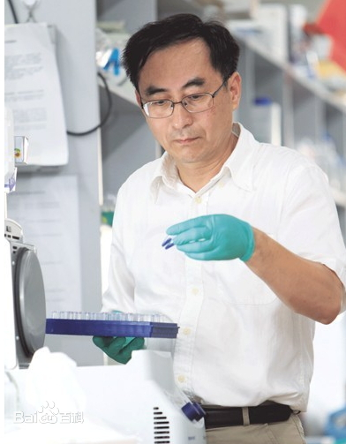

**Company Communication**

**Genscript**

**DESCRIPTION**

On the morning of September 8, we were fortunate to have a technical consultant from **GenScript** to analyze the advantages and disadvantages of our technology from a business perspective, as well as to provide answers to the technical bottlenecks encountered during the experiments. We also shared the conference with the students from Tianjin University, who also made some technical inquiries based on their own projects.

**VALUES**

Hp collects the problems generated by the wet group and feeds them back to the corresponding biotech company. After the questions are answered, hp shares the solutions to the wet group, **thus completing the process of problem-solving and making improvements to the project**.

**NEXT STEPS**

It enriched our knowledge of synthetic biology, increased our confidence in the project and optimized the experimental process.

